What happens when bargaining breaks down?
Federal Jurisdiction – Canada Labour Code

Notice to Bargain
If negotiations don’t commence once notice to bargain is made or if negotiations stop being productive and either side won’t budge then either party may file notice to dispute to the Minister of Labour.
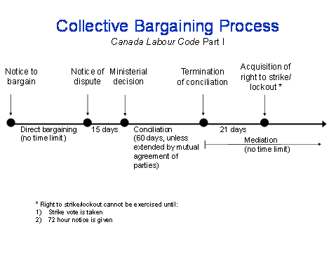
Notice of dispute
A notice of dispute is a formal written notification advising the Minister of Labour that the parties to a collective agreement have reached an impasse in their efforts to enter into, renew or revise a collective agreement and that the intervention of a neutral party is needed. By means of the notice of dispute, the Minister is requested to provide conciliation assistance to the parties.
As specified in Section 71 of the Canada Labour Code, a notice of dispute may be provided by either party to the Minister of Labour once the parties have bargained collectively and reached an impasse, or have failed to enter into negotiations within the time specified in Section 50 of the Code. When a notice of dispute has been served, the Minister has the option to appoint a conciliation officer, a conciliation commissioner, establish a conciliation board or choose to not provide assistance. Under normal circumstances, a conciliation officer, who is a member of the staff of the Federal Mediation and Conciliation Service (FMCS), is appointed no later than 15 days following receipt of the notice of dispute which has been filed in full compliance as stipulated in section 6 of the Canada Industrial Relations Regulations.

Conciliation
When the employer and unionized employees cannot reach an agreement, and negotiations to renew the collective agreement reach an impasse, the Minister of Labour may decide to appoint a conciliation officer.
However, the employer or the union representing the employees must make a request to the Minister by filing a "notice of dispute". Once appointed, the conciliation officer will meet the parties to assist them in resolving the impasse and reaching a collective agreement. Conciliation officers have considerable expertise in industrial relations gained through years of practical experience.
The conciliation process may take up to 60 days, although the parties may mutually agree to extend this time period.

Mediation
Mediation appointments are often made once formal conciliation procedures under the Canada Labour Code have been completed.
The Minister of Labour may appoint a mediator at any time, either at the request of one or both parties, or on the Minister's own initiative. The appointment of a mediator does not influence the acquisition of the right to strike or lockout. In almost all cases, mediation is provided by officers of the Federal Mediation and Conciliation Service.

Strike Vote
Furthermore, to strike, the union must have sought and received a positive strike vote from its members within the previous 60 days.
Strike or lockout notice must be filed in full compliance as stipulated in section 7 of the Canada Industrial Relations Regulations. So the decision to go to the members for a strike vote should be made taking into timelines of conciliation. Getting a strike vote doesn’t mean members will go on strike, it means they have the ability to go on strike if needed.

Strike or lockout notice
A strike notice is an advanced written notice that must be given by the union to the employer indicating the date and time on which a strike will begin. A lockout notice is an advanced written notice that must be given by the employer to the union indicating the date and time on which a lockout will begin.
If no agreement is reached during the conciliation process, there is a 21-day waiting period (known as a cooling-off period) before the parties may acquire the legal right to strike or lockout. As per article 87.2 of the Canada Labour Code, advance notice of strike or lockout to the other party and the Minister of Labour is required to be served at least seventy-two hours in advance.

Ending a Strike or Lock Out
The union can decide to end a strike and have members return to work and a company can end a lock out when ever they want. It usually occurs when a resolution is reached and a renewed collective agreement has been agreed to.

